LABORATORY CHAPTER №10

Topic1. CLOUD TECHNOLOGIES

Advanced search in Google
Punctuation and symbols. To refine your search results, you can use the special operators, and punctuation. Except as described below, the punctuation in search queries is not considered.
@ | Search by tags in social networks  Example: @agoogler
$ | Search prices  Example: nikon $400
# | Search for popular hashtags of relevant topics  Example: #todaynews
– | If you enter a hyphen before a word or a website address of the page with the word, or from this site will be excluded from search results. This is useful when searching for words that have multiple meanings, such as "Jaguar" (machine name) and "Jaguar" (animal).  Examples: jaguar -car speed and pandas -site: wikipedia.ru
" | If you put a word or phrase in quotes, the search results will show only the pages with those words in the same order in which they appear in quotation marks. Use quotes only if you are looking for an exact word or phrase. Otherwise, many useful results will be excluded from the search.
* | The asterisk substitutes any unknown word in the query.  Example: "Seven * measure, one cut off *"
.. | To get results that contain numbers in a given range, divide the value of two points with no space.  Example: camera 5000..9000 KZT.

Search operators
Search operators - these are words that are added to the search query to refine the results. They are not necessarily remember all these features are available on the advanced search page.
site: | Use this operator to get the results from certain sites or from these domains.  Examples: Olympic Games site: ntv.ru and Olympics site: .net
related: | Use this operator to find sites with similar content.  Example: related:kommersant.ru
OR | Use this operator to find pages that contain at least one of several words.  Example: OR Olympics OR Olympic Games
info: | Use this operator to get the address information on the Internet, including a cached version of the page, similar sites, and the page with links to specify.  Example: info:google.ru
cache: | Use this operator to find out how appeared a certain page when Google bots to crawl her for the last time. For example, if you are interested in a cached version of the website of MSU, use this query: cache: msu.ru

NOTE. When using searching operators do not add a space between the operator and the search query. For example, a search query site:korrespondent.ru will work and request site: korrespondent.ru - no.

Search tools
There is a panel that allows you to filter the results under the search bar. It will be a little different for different areas of the search (all results, pictures, blog, etc.), but the principle will not change - to provide you with maximum comfort and filtering capabilities:

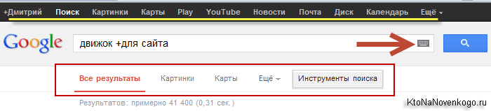

By default, all results are displayed to you, but you are free to limit the search to only pictures, maps, blogs, news, forums, videos, books, applications, etc .. For this are two further buttons and drop-down list of "More" button.

Advanced Search
To get more accurate results, use the advanced search. For example, you can choose sites that have been updated in the last 24 hours, or black-and-white photographs.
How to perform an advanced search
- Click the Advanced Search page:

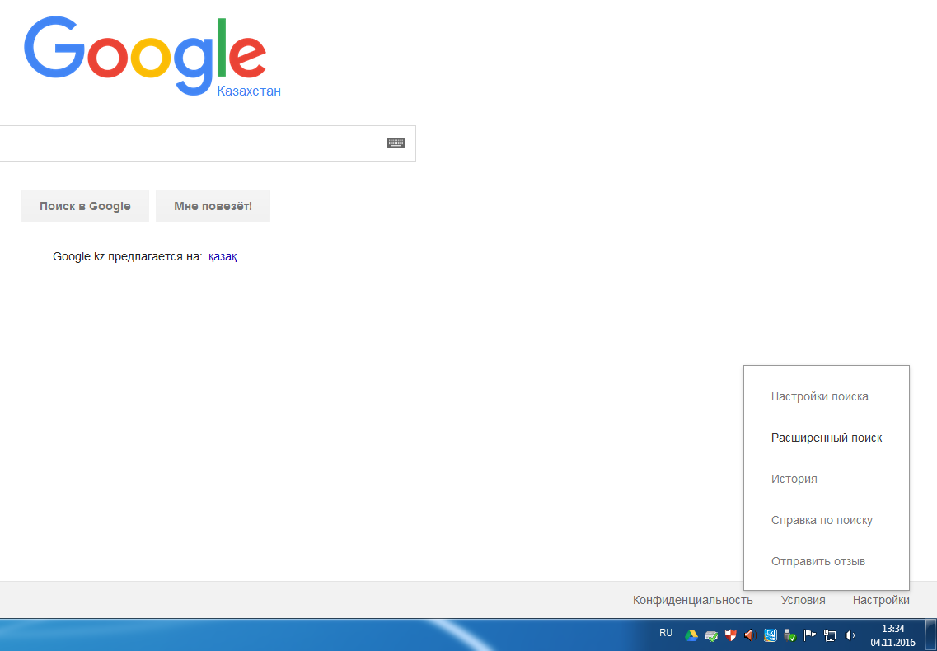

- Enter search terms in the "Find pages with".
- In the "Advanced Settings", set the filters.

Here you can choose filters:
- Language of the documents involved in the search
- Country on which the search will be carried out It will be possible to search only for new documents that have been indexed by Google in the past day, week, month or year
- You can limit the scope of searching with one site or domain zone (used already considered SITE operator).

There are a number of operators that allow you to search for keywords in certain parts of the documents are indexed by:
- Only the page title (the contents of the meta tag Title) - operator ALLINTITLE
- Only in the text documents are indexed - operator ALLINTEXT
- Only URLah pages caught in the Google index – ALLINURL
- Only texts (Anchor) leading to these sites links – ALLINANCHOR
- You can specify the file format in which you want to search (this is the purpose of the operator filetype), for example, when you want to find the answers you need in a PDF file (a request will look like - sites promotion filetype:pdf) or, for example, in word document ( essay on ... filetype:docx), which has been laid out in the network and indexed.

Topic2.GOOGLE DOCS ONLINE SERVICE

What is Google Drive?
Google Drive is a free service from Google that allows you to store files online and access them anywhere using the cloud. Google Drive also gives you access to free web-based applications for creating documents, spreadsheets, presentations, and more. Watch this video from Google to learn more about how Google Drive works.

Why use Google Drive?
Google Drive is one of the most popular cloud storage services available today, offering 15 gigabytes (15GB) of free storage space. If you've never used a cloud-based storage service like Google Drive before, take a moment to consider the advantages of keeping your files online. Because files can be accessed from any computer with an Internet connection, Drive eliminates the need to email or save a file to a USB drive. And because Drive allows you to share files, working with others becomes much easier.
Creating files on Google Drive
Google Drive doesn't just store your files; it also allows you to create, share, and manage documents with its own productivity apps. If you've ever used a suite like Microsoft Office, some things about Google Drive's apps might seem familiar. For instance, the types of files you can work with are similar to files that can be created with various Microsoft Office programs.
Below are some types of files you can create and share on Google Drive:
- Documents: For composing letters, flyers, essays, and other text-based files (similar to Microsoft Word documents)
- Spreadsheets: For storing and organizing information (similar to Microsoft Excel workbooks)
- Presentations: For creating slideshows (similar to Microsoft PowerPoint presentations)
- Drawings: For creating simple vector graphics or diagrams

To create a Google account:
- Go to www.google.com. Locate and select the Sign in button in the top-right corner of the page.
- Click Create an account.
- The signup form will appear. Follow the directions by entering the required information, such as your name, birth date, and gender.
- Review Google's Terms of Service and Privacy Policy, click the checkbox, then click Next step.
- The Create your profile page will appear. Click Add a photo if you want to add a photo to your Google+ profile. If you don't want to set a profile photo at this time, click Next step.
- Your account will be created, and the Google welcome page will appear.

Accessing Google Drive
Once you've set up your Google account, you can access Google Drive by going to http://drive.google.com in your web browser.
You can also navigate to Google Drive from any Google page (such as Gmail or Google search) by selecting the grid icon near the top-right corner, then clicking Drive.
Document upload to Google Drive
- Go to Google Drive. If you are not on the page of Google Drive, click on it using the URL. This can be done at http://drive.google.com/
If you have not logged into your account, do it now.
- Click on the "Create" button. Then select the "Upload Files" or "Upload Folder".
- After selecting a file download options or folder Explorer window will appear, from which you can select a file or folder with the files.
- Find the file you want to upload. Browse the folders and subfolders on your computer until you find the file you want. Click on the image to select it.
- Click on the "Open" button. Click on the "Open" button to your chosen file has been uploaded to the disc.
- Either you can double-click on the file name or icon of the file to be downloaded.
- Note that the file is loaded on the disk with the same name that was on your computer.

Edit the document. Now you can edit your document, as well as any other documents in Google Drive.Managing your files
After you've been using Google Drive for a while, you might find yourself having a difficult time keeping track of all of your files. Drive offers several features to help you manage and organize them.

To create a folder:
- From Google Drive, click the New button, then select Folder from the drop-down menu.
- A dialog box will appear. Enter a name for your folder, then click Create.
- Your folder will appear on the left below My Drive. You may need to click the drop-down arrow to see your folders.

To move files into folders:
- Click and drag the file to the desired folder.
- The file will appear in the selected folder.
To add multiple files to the same folder, press and hold the Ctrl key (or Command on a Mac), then click to select each desired file. When you're ready, click and drag the files to the desired folder.
To delete a file:
Deleting a file from your Google Drive is similar to deleting a file from your computer. You will have to move the file to the Trash folder and then delete it permanently, just like you would delete a file from the Trash or Recycle Bin on your computer.
- Select the file you want to delete, then click the Remove button to move the file to the Trash folder.
- Select Trash in the left navigation pane.
- The Trash folder will appear. Click Trash near the top of the screen, then select Empty Trash. The files will be permanently deleted.

To preview a file:
Previewing files is a great way to make sure you're opening the right version of a file or to take a quick look at files without opening them.
- Select the file you want to preview, then click the Preview button.
- A preview of the file will appear.

Right-clicking
Right-clicking allows you to access the full list of actions for any file. Most of the actions listed here are accessible in other places on Google Drive, but it serves as a great shortcut.

To create a new file:
- From Google Drive, locate and select the New button, then choose the type of file you want to create. In our example, we'll select Google Docs to create a new document.
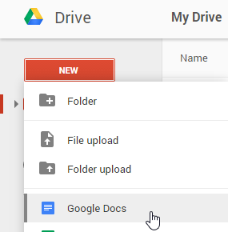
- Your new file will appear in a new tab on your browser. Locate and select Untitled document in the upper-left corner.
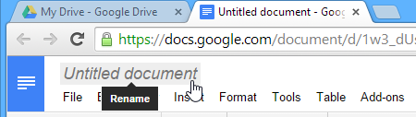
- The Rename dialog box will appear. Type a name for your file, then click OK.
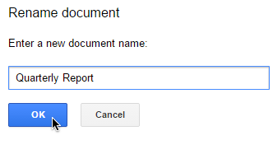
- Your file will be renamed. You can access the file at any time from your Google Drive, where it will be saved automatically. Simply double-click to open the file again.
You may notice that there is no Save button for your files. This is because Google Drive uses autosave, which automatically and immediately saves your files as you edit them.
Sharing and collaborating on files
Google Drive makes sharing your files simple. It also allows multiple people to edit the same file, allowing for real-time collaboration.
Sharing files
Whenever you share a file from your Google Drive, you can let others view and even edit that same file. While you can share any file stored on your Google Drive, it's important to note that you can only use the collaboration features for files created within your Drive.
Let's look at the example of user, an art teacher who uses her Google Drive to organize letters, lesson plans, and more. Users's files include:
- Files she keeps private, like her spreadsheet with classroom expenses
- Files she lets others edit, like the lesson-planning documents she creates with her co-teacher
- Files she shares publicly and doesn't let others edit, like the newsletters and announcements she shares with her students and their parents
- Files others share with her, including ones she can edit, like her co-teacher's supply inventory; and ones she can't, like a schedule sent to her by the principal
As you can tell, no single sharing setting would be right for all of files. The settings you choose for each of your shared files will probably depend on why you're sharing it in the first place.
When you share a file with a limited group of people, your collaborators must sign in with a Google account to view or edit the file. However, when you share with a larger group or make the file public, your collaborators will not need a Google account to access the file.

To share a file with a limited group of people:
- Locate and select the file you want to share, then click the Share button.
- A dialog box will appear. In the People box, type the email addresses of the people you'd like to share the file with. If you want, you can add a message that will be emailed to the people you share the file with.
- Click Send. Your file will be shared.
For more control over your files, you can click the drop-down arrow to decide whether people can edit, comment on, or simply view the file.

Sharing with a link
You can easily share a file with a larger group of people by providing a link to any file in your Google Drive. A link is basically a URL or web address for any file you want to share. This can be especially helpful for files that would be too large to send as an email attachment, like music or video files. You can also share a file by posting the link to a public webpage. Anyone who clicks the link will be redirected to the file.
To share a link:
- Locate and select the file you want to share, then click the Share button.
- A dialog box will appear. Click Get shareable link.
- A link to the file will be copied to your web clipboard. You can then paste the link in an email message or on the Web to share the file. When you're finished, click Done.

Files shared with you
Users can also choose to share files with you. These files will appear in your Shared with Me folder. However, if you'd prefer to access a file from your Google Drive without switching to this view, you can move it. To do this, navigate to your Shared with Me folder, hover the mouse over the desired file, then select Add to My Drive.
Now you can choose from 4 levels of access for users who have passed the following link:
- Turned off. The document is not available to all.
- View. Users will be able to read the document and copy its contents.
- Comment. Users can write comments in the margins, or advise changes. But to change something in the document can not.
- Edit. Everyone who went to the link to the document can do anything. Be careful with this.

Collaborate on documents
After you have distributed accesses the right users, they can get to work. Those who are only allowed to watch, nothing will not be able to do. Those who are allowed to edit - are free to do anything. But the most interesting part - is commenting. Commentators can not edit the text on their own, but they can give advice.
You (and other users) can write notes in the margins. To do this, select some text, invoke the context menu and click "Leave a comment". Or simply click on the icon that appears to the right as soon as you have something to highlight.
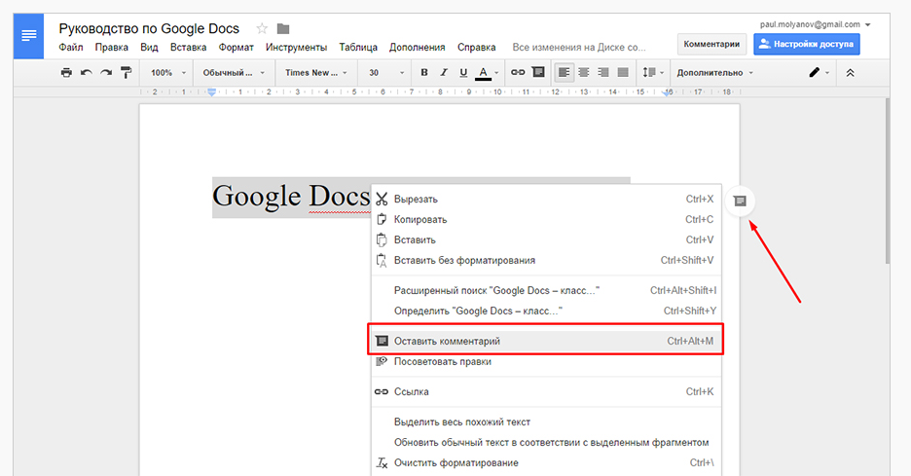
Where you can write your comment on the text or add a reminder. For example, add a title.
Or rewrite the wrong sentence. To remove a comment - click on the button "issue resolved." Note go to the archive. If you want to completely delete a comment, click on the button with three dots and select "Delete." To see the file, click on the button "Comments" in the upper right corner.

Suggest changes
A very interesting feature. It allows you to append text or remove the existing fragments. The action does not take place at once, and with the permission of the owner.
To go to the edits mode, open the list under the button "Access Settings" and select "advise".

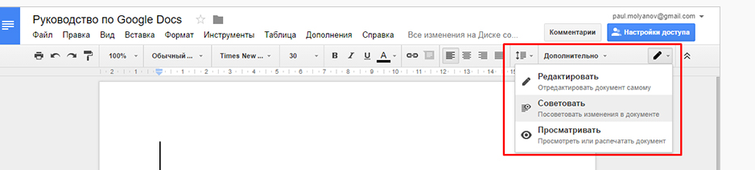

Now you will edit the text, and advise changes. Colleagues or yourself, if you are working alone. Members are always with "Commenting" access level in this mode. In the fields will appear comment a proposal to approve or reject the changes.

